THE GLOBAL (E - Newsletter)
Vol: 1 (June - Sept)

FROM THE PRINCIPAL’S DESK
The launch of the Eklavya Global School in June 2016 was a major step for the Management of Kids Edutech - some said they were hoping for something like this in Junagadh since years. Looking back, I am impressed by the progress made by this small institution in the short span of one year. We could successfully get our CBSE affiliation done on 06-06-2017 with the Affiliation No: 430325.Our students have grown enough to dream of their future, understand their strength which, in fact would be the keystone to success. It is my proud privilege to be a part of this institution. I now stand delighted to introduce the first edition of THE GLOBAL, the Newsletter of Eklavya Global School. We intend to make it a regular publication and to use it to keep you in touch with news and developments which relate to our School and its implementation. In this and future editions, we shall be reporting decisions, discussions and events which take place in our campus keeping students at the centre of affairs... Through the first edition of THE GLOBAL, the students and teachers are making an effort to vent their experiences and learning at Eklavya Global School.
Hope you enjoy reading the Digi view of our maiden effort.
Happy reading!
DIARY OF EVENTS
(June - September)
CELEBRATIONS
- International Yoga Day
- Doctors’ Day
- Raksha Bandhan
- Krishna Janmashtami
- World Photography Day
- Teachers’ day
EVENTS CONDUCTED
- First PTM of the session for grades I - VIII
- A seminar to spread the awareness on myths and superstitions related to snakes by
Dr. Punil Gajjar
- A short seminar on oral hygiene by
Dr. Bhoomika Raiyanai.
- Tree plantation in and around school premises under the supervision of Mr. Punil Gajjar and Mr. Rasik Bhatt.
- A photography workshop one day prior to the world photography day by Dr. Mayank Shah.
PARTICIPATIONS IN COMPETITIONS
- 4 students participated in inter school cultural meet, organised by ABPS, Veraval.
- Few of our students participated in Khel Mahakumbh under different categories.
WORKSHOPS ATTENDED
- 8 Teachers attended skill building programme at River side school, Ahmedabad.
- Teachers attended 2 days Cambridge English Teacher training programme.
Resource person: Mr. Adib. J. Modak
- Our Principal Ms. Jessy Roy attended Principals’ conference at Gandhi Nagar organised by CBSE.
- Mr. Pradnyesh Pitre attended a conference of British Council at Jamnagar.

Panorama of events conducted during June to September 2017
International Yoga Day (June 2017)

The school celebrated International Yoga Day in unanimity with all the schools of our nation. Students and Teachers together performed different asanas and yoga exercises to mark the beginning of a regular yoga schedule.
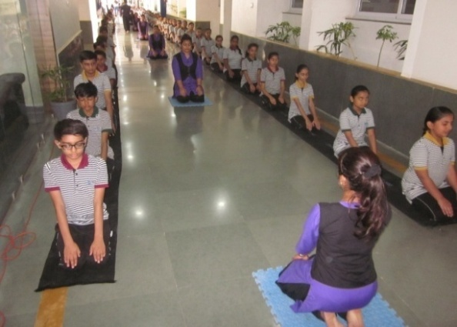
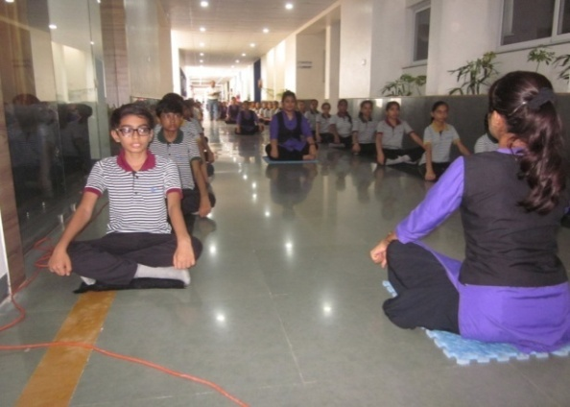
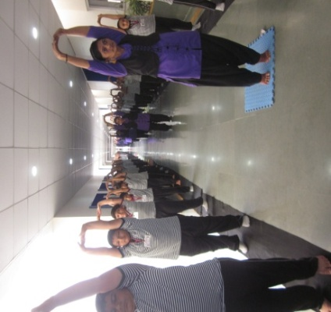

Seminar on oral hygiene (July 2017)

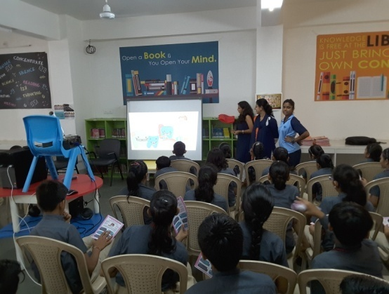
“Know Your Teeth”, a small seminar was conducted by Dr. Bhoomika Raiyani on oral hygiene.Students were explained about the most common oral diseases and the remedy to over come it.
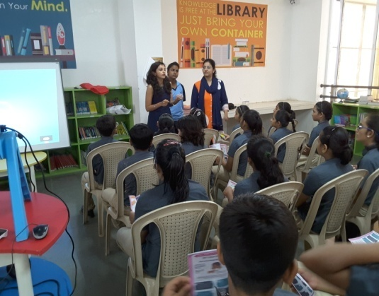
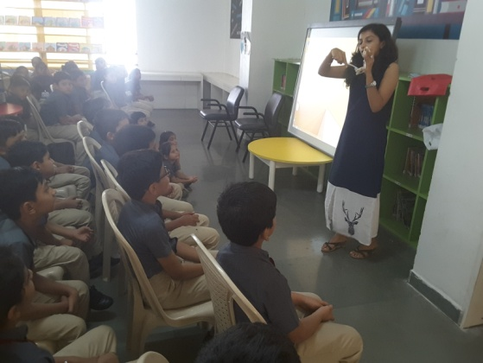

Seminar on myths & beliefs related to snakes (August 2017)

A very fruitful seminar conducted by Mr. Punil Gajjar, professor in Junagadh Agricultural University, on the topic MYTHS-BELIEFS-SNAKES in school campus. Students were given the awareness about poisonous and non poisonous snakes. They were taught the techniques to catch the snakes in a proper way.
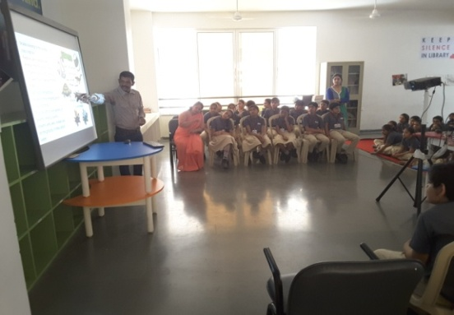
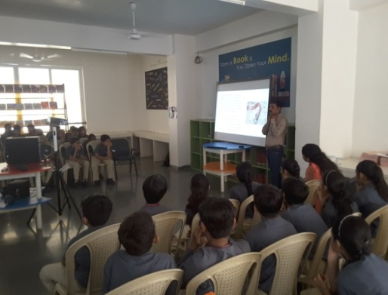
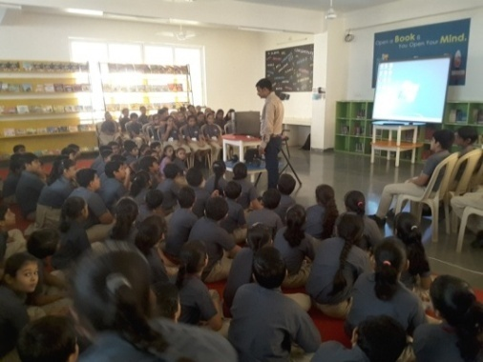

Raksha Bandhan celebration (August 2017)
EKLAVYA GLOBAL SCHOOL has made an innovative experiment with the ideology of "BROTHERHOOD". Students made colourful Rakhis; celebrated the festival of brotherhood by tying self made Rakhis to the mini family members grouping the students of our school. Students of Grade VIII volunteered the celebration of brotherhood and vouched “the celebration doesn't end here, but will; move on and on all through their lives at Eklavya Global School." It was a scene to watch when teachers & students sat together, sharing Rakhis, sweets and stories.
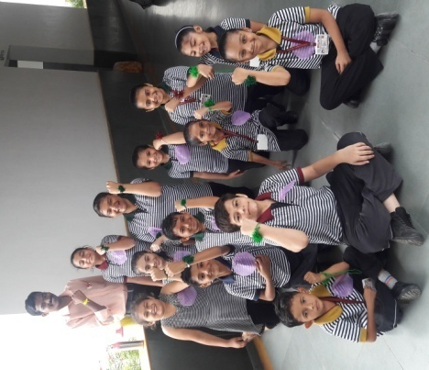
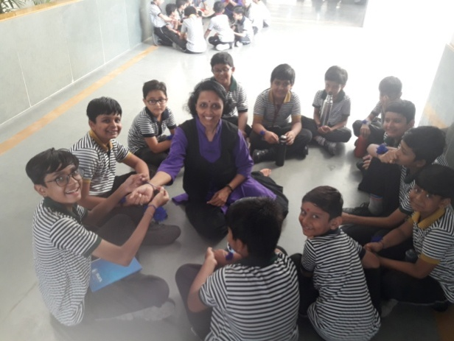
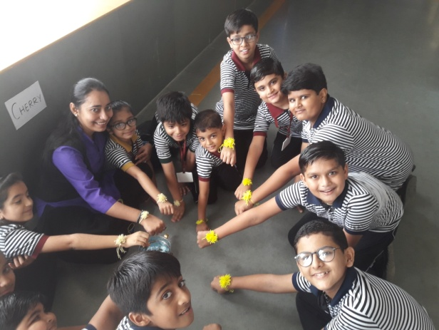

Tree Plantation (August 2017)
It has been a great day for our school when a team of students under the able guidance of Mr. Punil Gajjar and Mr. Rasik Bhatt visited our campus with a mission to make the surrounding area green by planting saplings of multiple varieties.
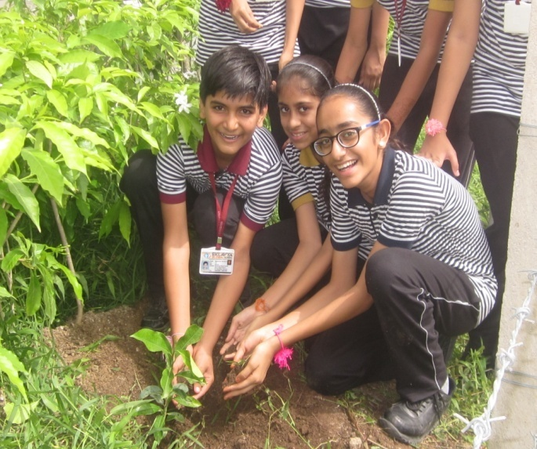
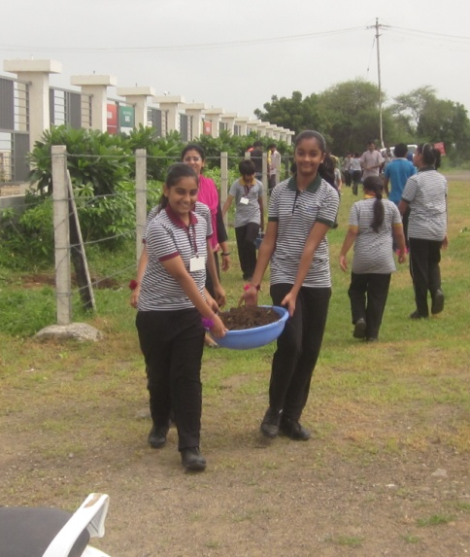
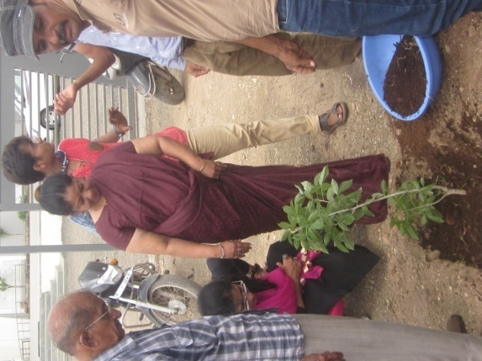
EKLAVYANS are waiting for the bloom of a yard with colourful trees....

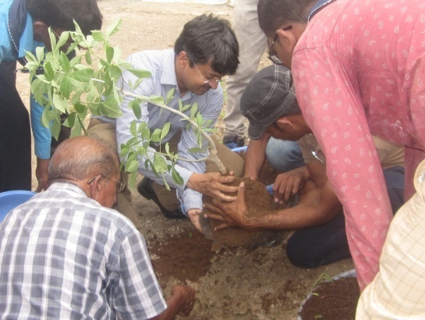

Krishna Janmashtami celebration (August 2017)
MANNEQUIN ACT
Students and staff at Eklavya Global School have celebrated Janmashtami all with a difference. They manifested their skills of dramatics by depicting different life events of Lord Krishna using the technique of Mannequin Act. Each House projected two Mannequin Scenes in sequence and made the judges spellbound through their immaculate demonstration. We appreciate the views, ideas and input of our very talented teachers
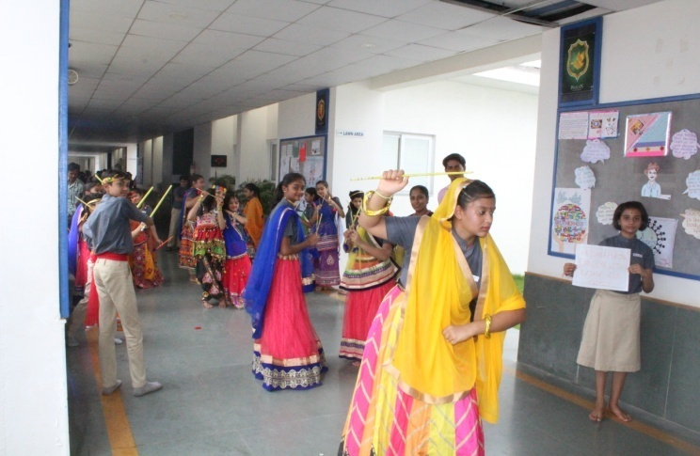
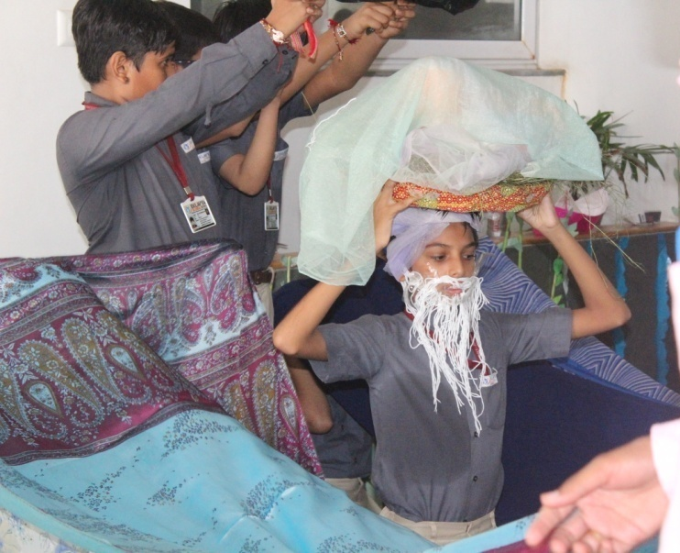
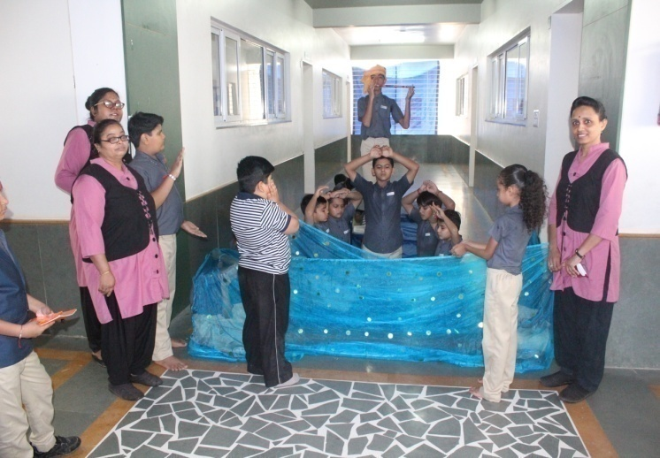
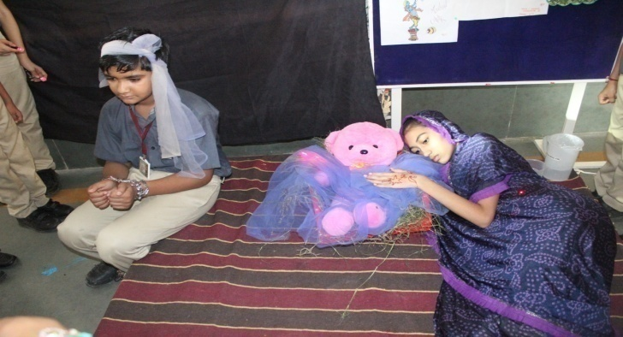

Photography Workshop (August 2017)
“PHOTOGRAPHY IS AN ART OF DRAWING OR WRITING IN LIGHT”
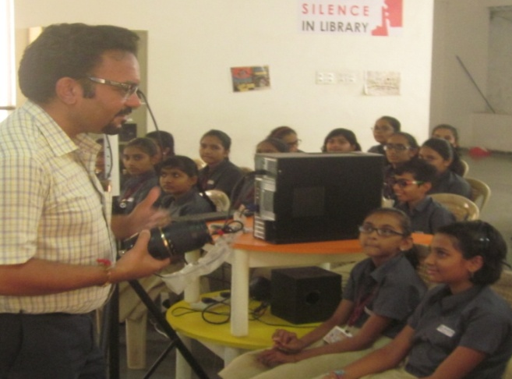
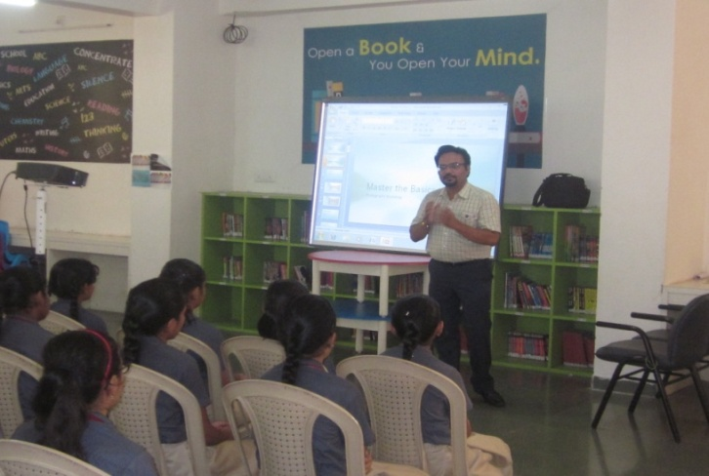
A small workshop on “Techniques of clicking better photographs” was conducted in school campus on the occasion of “World Photography Day”. Dr. Mayank Shah, one of our parents, a paediatrician by profession and an expert in photography, conducted the workshop. Students of Grades V - VIII attended the workshop.

World photography day @ Bhavnath Taleti (August 2017)
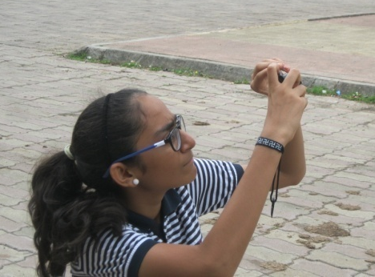
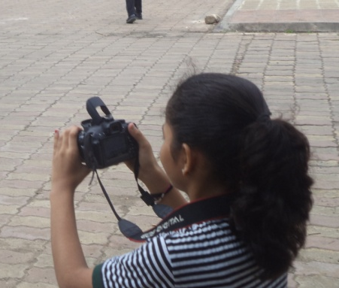
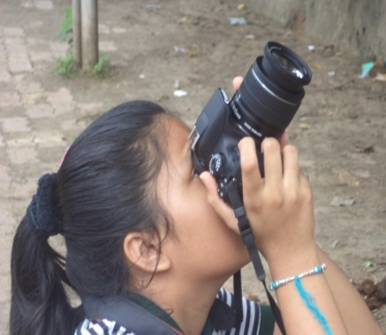
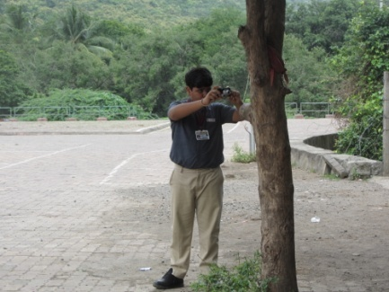
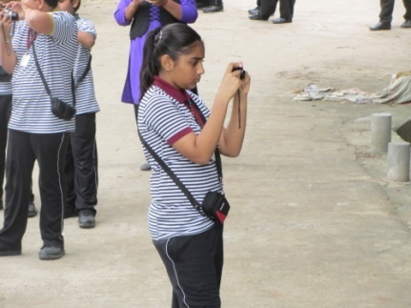
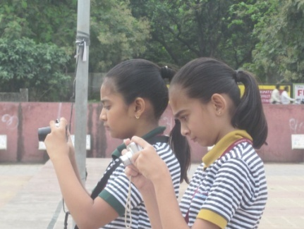
Our students of classes VII / VIII & IX took part in a’ photo shoot competition” on account of World Photography Day celebration on 19/8/2017. We could thereby identify the potential young photographers among the participants. Our next step is to assist the students in nurturing their skills and help them dream to be dynamic photographers.

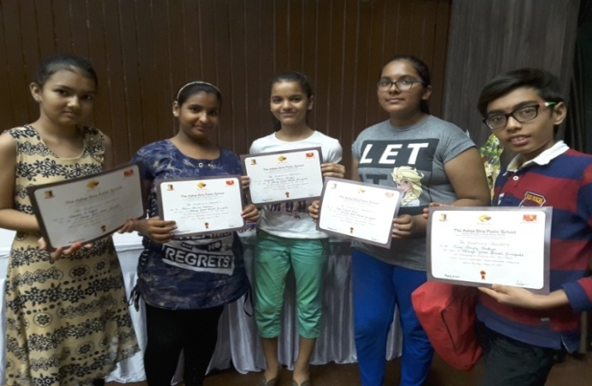
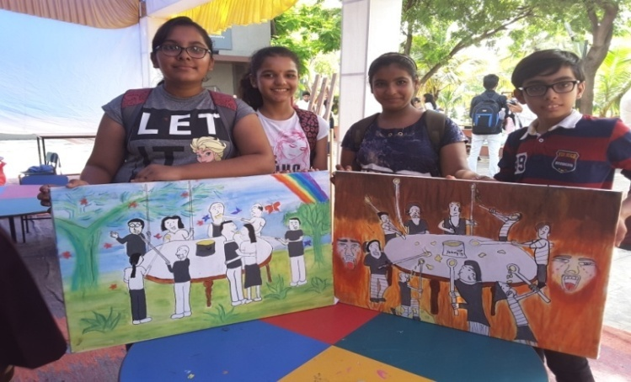
Cultural meet @ ABPS Veraval (August 2017)

PARTICIPANTS: VEDANTI, BHOOMI, NUZHAT, DIYA AND RISAJ
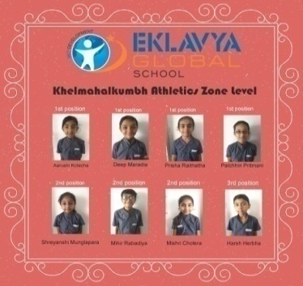
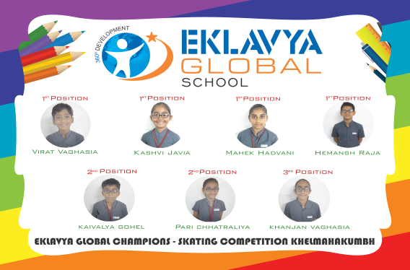
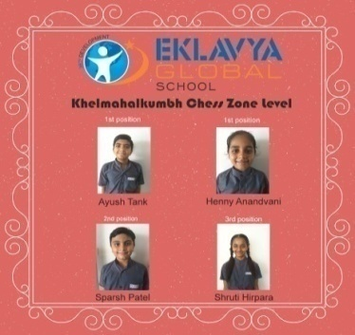
Khel Mahakumbh (August 2017)

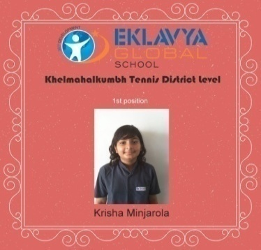
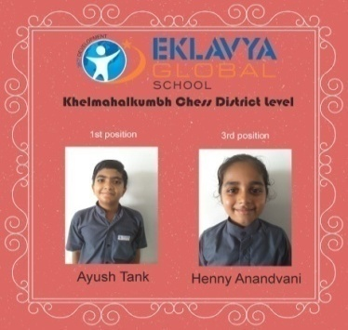
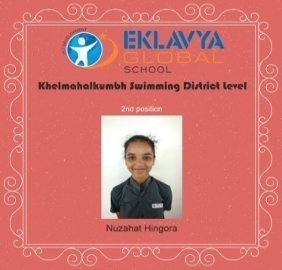

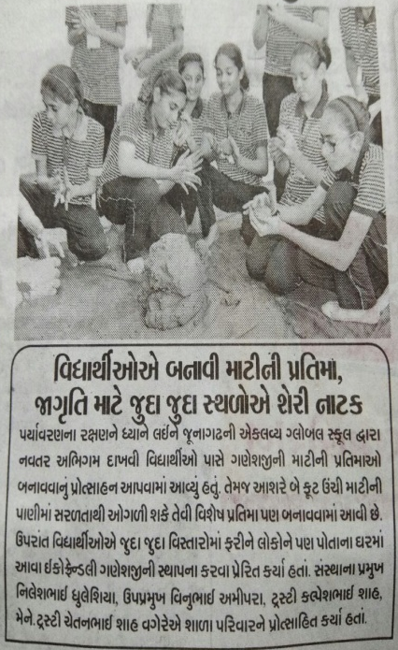
An appeal to use Eco-Friendly Ganesh Idol by our students
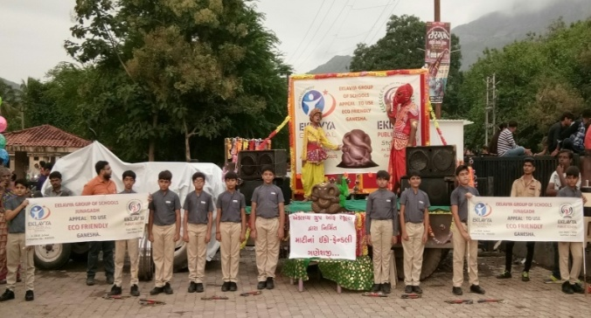
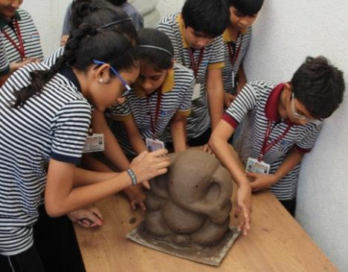

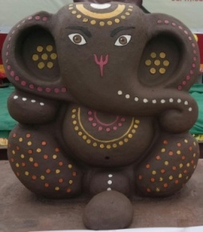
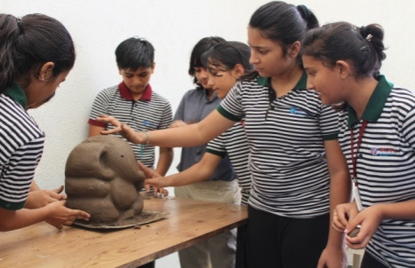

Teachers’ Day Celebration (September 2017)
Teachers Day was celebrated with all good spirit. Students of senior classes managed the affairs of school on that day proving their managerial skills. While doing so, they have realized the amount of hardship their real teachers put in.
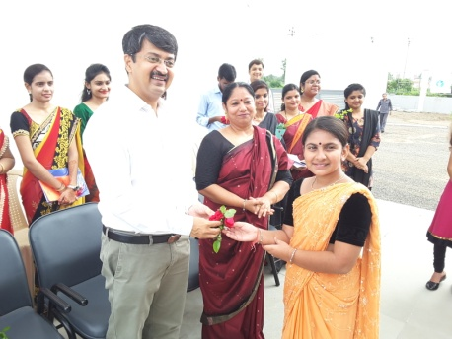
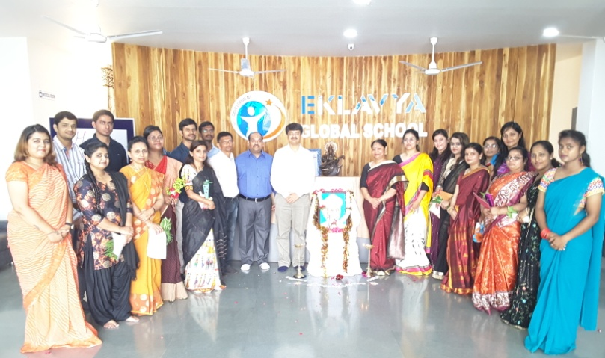
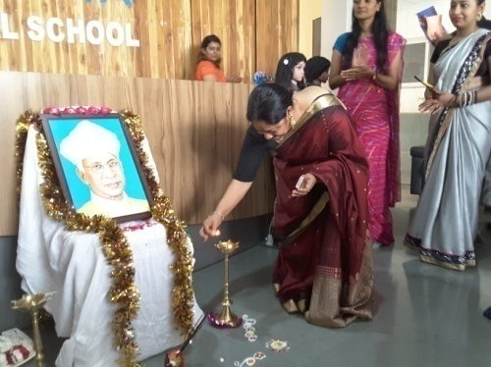

हिंदी भाषा दिवस का आयोजन (September 2017)
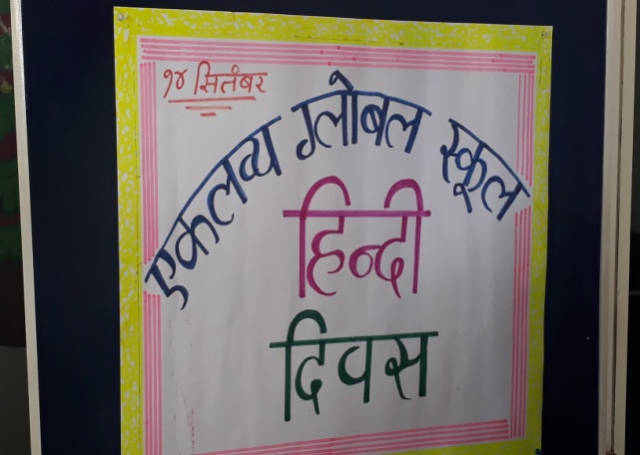
विद्यालय में हिंदी भाषा दिवस बड़े ही उत्साह और उमंग के साथ मनाया गयाI विद्यालय में इस अवसर पर वक्तृत्व स्पर्धा और तात्कालिक भाषण स्पर्धा का आयोजन किया गया जिसमें विद्यार्थियों का सहभाग सराहनीय रहाI

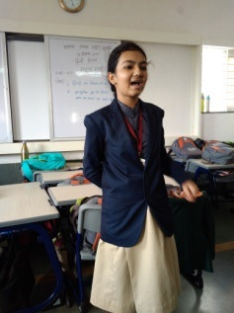
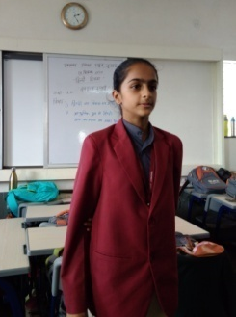

Teachers’ training programme @ Riverside school (September 2017)
We treat the entire school as one body and mind of several wise ladies and gentlemen. Out of the many affairs, academics form the basis of this ‘body structure’. We focus on academic enrichment programmes with the help of our enthusiastic teachers. Teachers in our school are regularly handheld by efficient menders from excellent academic background. We have so far conducted rounds of in house workshops by Cambridge English, UK. A team of our teachers visited THE RIVERSIDE SCHOOL, Ahmedabad to learn systems to add on to our existing system of academics. I sincerely believe to rise in leaps and bounds with the help of such enrichment programmes.
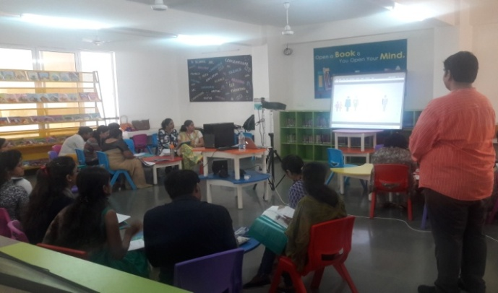
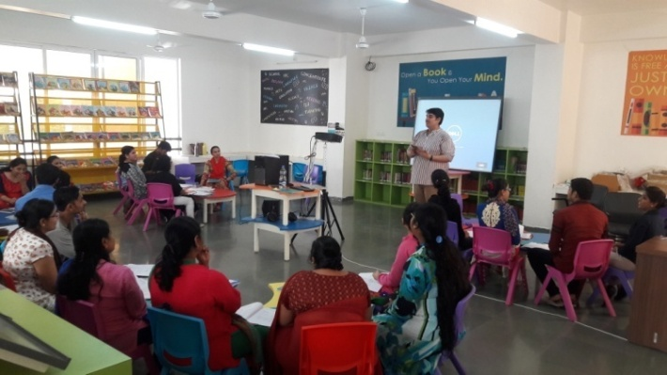

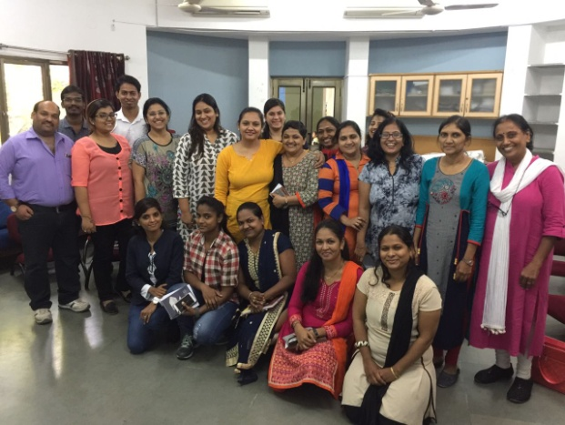
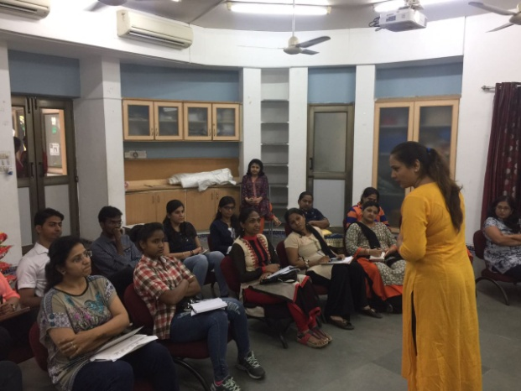

Earthen Diya making (September 2017)
We have stepped into the shoes of modernism quite for some years and have been conveniently slipping away from the lap of nature. Earthen articles were a ‘must’ for our festivals. As with the advent of technology we began to add glitters, heavy sound and flash lamps on every celebration. “Sorry to see the dying status of our ancient artefacts”. We have forgotten all about our earthen lamps which had lots of divinity. It is very essential to uphold the original culture of India. The students and staff of Eklavya Global School are trying all their means to spread awareness about the use of ‘handmade Lamps’. Able potters from the vicinity were called in to teach the students of our school the art of making earthen lamps. Now we have made ample number of lamps which would be supplied to local homes in and around Junagadh to be lit during Diwali.
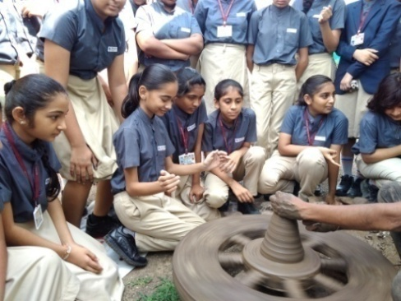
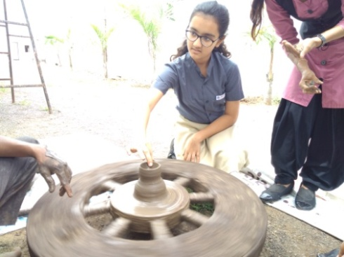
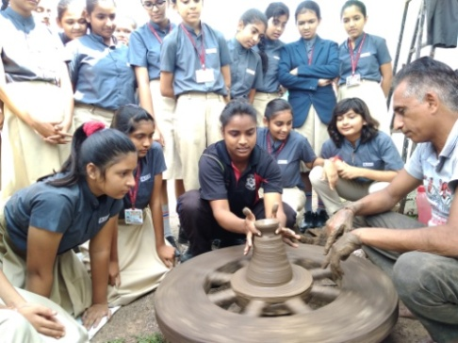

Principal’s Execellence Award (September 2017)
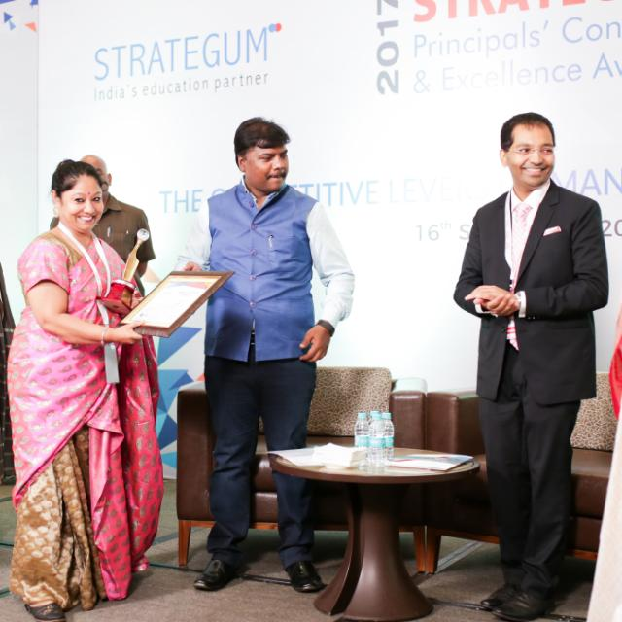
It was an amazing day to all the members of Eklavya Global Family when our Principal Mrs. Jessy Roy was honoured for her outstanding contribution towards school education by the Stratagem Educare in the hands of Education minister for Cabinet, Chhattisgarh during Principals’ conclave at Raipur on 17/9/2017. It is a matter of pride to the institution as it proves “Eklavya Global School is in the safe hands of true educationists”. We wish her all the best for her future endeavours.

Competitions at a glance
There were many competitions arranged in the school till date. Some of which were inter house and some were individual. Details are given in textual form and related pics can be seen randomly.
- Inter House mannequin act competition. The results are as follows...
- Best depiction (Gryffindor House)
- Best still view ( Pelican House)
- Best photogenic ( Ravenclaw House)
- Best representation of theme ( Hufflepuff House
- In Inter House One act play competition, Pelican House was judged outstanding with the theme
“Social networking - a boon or a curse?”
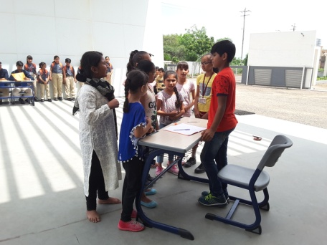
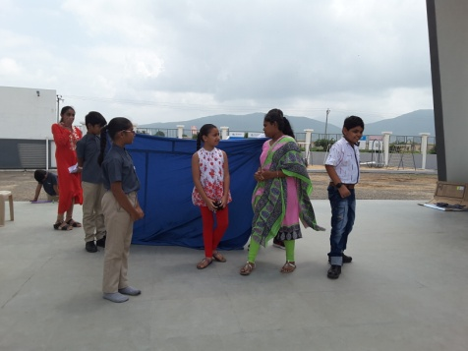
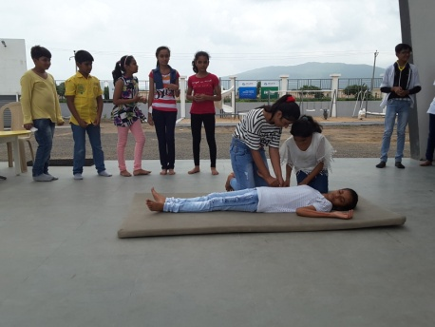

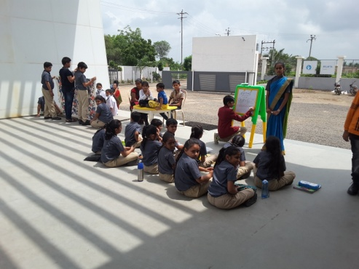

Results of intra class competitions
GRADE - III

GRADE - I

- Poem recitation
- Arnav Pitre - Winner
- Ananya Kirtane - I Runner up
- Sameer Shamadara - II Runner up
- Story telling
- Arnav Pitre - Winner
- Sarabjeet Kaur - I Runner up
- Ananya Kirtane - II Runner up
- Drawing and Colouring
- Arnav Pitre - Winner
- Ananya Kirtane - I Runner up
- Aarav Savsani - II Runner up
- Sand bag balancing
- Jayraj Rathod - Winner
- Bhavya Anandwani - I Runner up
- Karan Kanjani - II Runner up
GRADE - IV

GRADE - II

- Poem recitation
- Swara Sherathiya - Winner
- Riya Gangdev - I Runner up
- Vedant Dholakiya - I Runner up
- Neev Vachhani - II Runner up
- Story telling
- Teerth Joshi - Winner
- Freya Vaghela - I Runner up
- Naqsh Godhwani - II Runner up
- Drawing and Colouring
- Sanvi Vachhani - Winner
- Swara Sherathiya - I Runner up
- Malay Minjrola - II Runner up
- Sand bag balancing
- Freya Adhvaryu - Winner
- Dhrupal Radadiya - I Runner up
- Shreyanshi Mungalpara -
II Runner up

- Elocution
- Kavish Oza - Winner
- Amber Hasbe - I Runner up
- Jayandrashree Polepalli - II Runner up
- Extempore
- Hemagna Majumdar - Winner
- Urja Panchamiya - I Runner up
- Kaivalya Gohel - II Runner up
- Drawing and Colouring
- Aneri Jadav- Winner
- Hiya Makvana - I Runner up
- Madhur Patadiya - II Runner up
- Sand bag balancing
- Aneri Jadav - Winner
- Sparsh Ratanghayra - I Runner up
- Tirth Rathod - II Runner up

- Elocution
- Dhruva Kansagara - Winner
- Niva Hariyani - I Runner up
- Aash Sadariya - II Runner up

- Extempore
- Palak Patel - Winner
- Aash Sadariya - I Runner up
- Deep Maradiya - I Runner up
- Mishri Cholera - II Runner up

- Drawing and Colouring
- Palak Patel - Winner
- Teerth Bamroliya - I Runner up
- Hiya Thakkar - II Runner up

Results of intra class competitions
GRADE - V

- Drawing and Colouring
- Niva Kaneriya - Winner
- Mahek Hadvani - I Runner up
- Chirag Hirani - II Runner up

- Elocution
- Sparsh Patel - Winner
- Palak Maradiya - I Runner up
- Daman Lunagariya - II Runner up

GRADE - VII

- Extempore
Winners
- Charvi Ajwani
- Palak Maradiya
- Drawing and Colouring
- Diya Shah - Winner
- Nuzhat Hingora - I Runner up
- Shruti Hirpara - II Runner up

- Prachi Shah
I Runner up
- Krushika Rabara
- Palchin Pritmani
- Pratik Dave
- Sparsh Patel
II Runner up
- Krupali Nimavat
- Balancing (Grade - IV & V - Girls)
- Henny Anandwani - Winner (Grade - V)
- Prachi Shah- I Runner up ( Grade - V)
- Krushika Rabara - II Runner up (Grade - V)
- Dharika Vithlani - II Runner up (Grade - IV)

- Virat Vaghasiya
- Priyansh Devmurari
- Drawing and Colouring
- Krushika Rabara - Winner
- Barsali Chavda - I Runner up
- Rudra Viradiya - II Runner up
- Balancing (Grade - IV & V - Boys)
- Virat Vaghasiya - Winner (Grade - V)
- Sparsh Patel - I Runner up ( Grade - V)
- Sahil Vaghela - II Runner up (Grade - V)

GRADE - VI

- Extempore
- Misha Jagani- Winner
- Skipping (Grade - IV & V - Girls)
- Rudra Viradiya - Winner (Grade - V)
- Palak Patel - I Runner up (Grade - IV)
- Palchin Pritmani - II Runner up (Grade - V)

- Ram Patel - I Runner up
- Misri Koradiya - II Runner up
- Kavya Bhanderi - II Runner up
- Drawing and Colouring
- Skipping (Grade - IV & V - Boys)
- Shubham Viradiya - Winner (grade - V)
- Prasanna Chothani - I Runner up (Grade - V)
- Deep Maradiya - II Runner up (Grade - IV)

- Harshita Ukani - Winner
- Pujan Dhaduk - I Runner up
- Ansh Dhulesiya - II Runner up

GRADE - VIII

Results of intra class competitions (clubed classes)

Extempore competition for

Results of intra class competitions (clubed classes)
- Balancing (Grade - VI, VII & VIII - Boys)
Shreeyut Butani - Winner (Grade - VII)
Arjun Dhaduk- I Runner up ( Grade - VI)
Sujal Sanandiya - II Runner up (Grade - VI)

- Rope skipping (Grade - VI, VII & VIII - Boys)
Risaj Pokiya- Winner (Grade - VIII)
Kavy Bhanderi- I Runner up (Grade - VI)
Rudrajraj Zala - II Runner up (Grade - VII)

- Rope skipping (Grade - VI, VII & VIII - Girls)
Pushti Hirpara- Winner (Grade - VII)
Nuzhat Hingora- I Runner up ( Grade - VIII)
Harshita Ukani - II Runner up (Grade - VI)

- Balancing (Grade - VI, VII & VIII - Girls)
Mahek Hadvani - Winner (Grade - VII)
Radhika Popat - I Runner up ( Grade - VIII)
Niva Kaneriya - II Runner up (Grade - VII)

- Photography (Grades - VI, VII & VIII)
I position - Hirva Kotecha (VII)

II position - Diya Shah (VIII)

III position - Hemansh Raja (VI)
III position - Shreya Shah (VIII)

- Extempore (Grades - VII & VIII)
Krisha Radadiya Grade - VIII I position
Hetvi Karia Grade - VIII I position
Vedantiba Vaghela Grade -VII II position
Nirali Rathode Grade - VII II position
Shreya Shah Grade - VIII III position
Diya Shah Grade - VIII III position
Selvi Mehta Grade - VII III position

Our Initiatives
- We strongly believe that during childhood, at least till the age of 13, the child should be allowed to play the maximum; there should be minimum or even no exposure to tuitions or coaching of any kind. If he/she is learning a sport or dance or music it should be because he /she is enjoying that particular activity, not because they have to learn a sport as everybody else is learning. Parents need to guide them, teach them but also give them a bit of freedom. Now, by freedom we don’t mean giving them a cell or unlimited access to the computer or not knowing what they are doing in school, what company they are in. By freedom we mean letting them spend their time the way they want. If they want to spend the day reading a book, they should be allowed to do that; if they want to paint they should be encouraged to do it, if they want to play for 3 hours they should be allowed to do so. Remember that childhood days are the only days where we can be free in the true sense of the word — and develop ourselves fully — without life’s pressures. In order to make our students walk in and walk out the school campus bag free, we have planned and executed ‘Bagless Education System ‘with the kind support of our laborious teaching staff. We are happy to see the’ happy go lucky students of our school’ who ease their burden by learning together, playing together and being together, all in 7 hours.
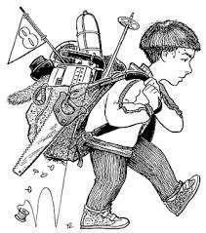
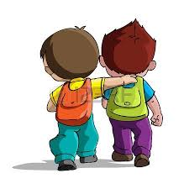

- Moral Values are the worthy ideals or principles that one follows to distinguish the right from the wrong. These ideals or virtues are considered worthy in building up the character of an individual.

Moral Values refer to the good virtues such as Adaptability, brotherhood, liberty, love, Honesty, integrity, truthfulness, compassion, helpfulness, respectfulness, hard-work, etc.

Students are the future of India. The future of our country depends upon the moral values imparted to them during their student life. Moral lessons should be properly implemented among students in school and colleges. We at Eklavya Global School give utmost importance to moral values. We have chosen our bulletin boards to depict significant ideologies prepared by the students of all four houses under the guidance of their house masters, creating social awareness of values and their application in their daily lives. Students could so far depict four values quite successfully.

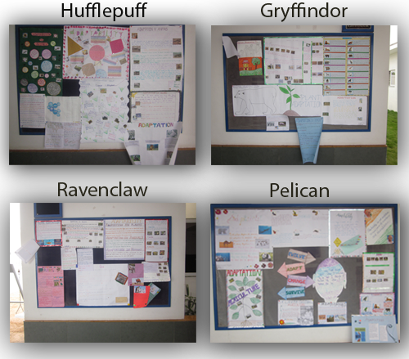

- Every child is born unique and we really believe it. Competitions have become inseparable to parents and students, though for us, each student is precious. Our hearts break when a child suppresses his/her emotions when he/she loses a competition. A child who fails to compete with a stronger counterpart goes home weeping for the loss or cribbing on the justice of the judgement or taking a resolution vouching ‘no more participation’. All these have made us structure out a master certificate which would be given to every student of our school at the close of every academic year marked with symbols for participation and special achievements. Thus every child will have a smile on his/her face.

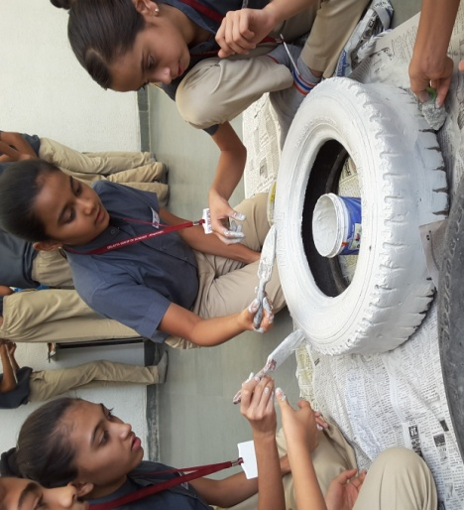
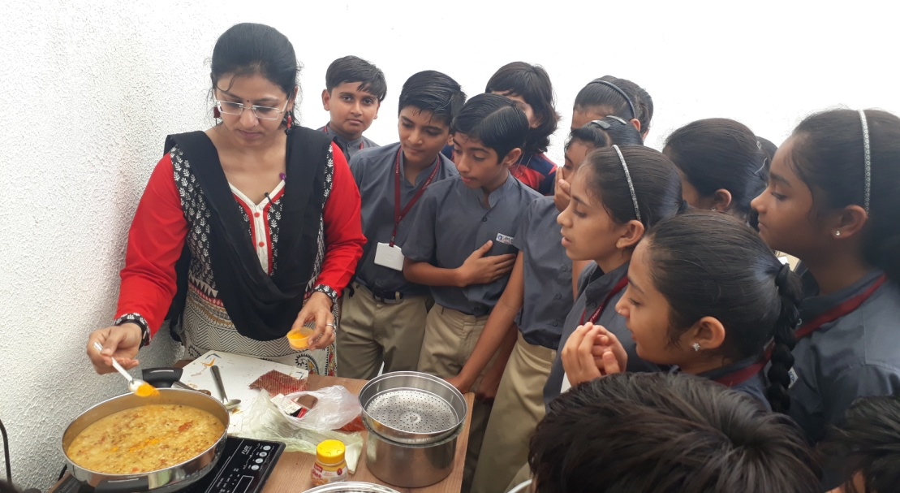
Activities at a glance

BEST OUT OF WASTE
MAKING OF DAL TADKA
(An English lesson in an Indian kitchen)
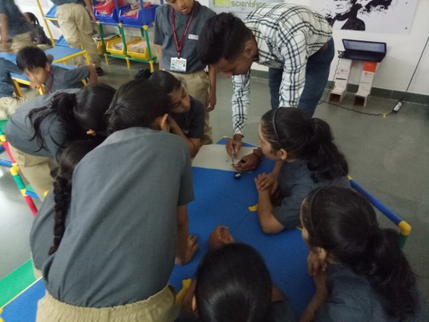
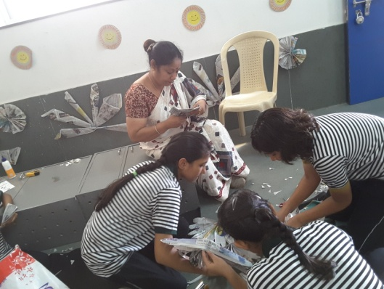

A SESSION IN ROBOTICS LAB

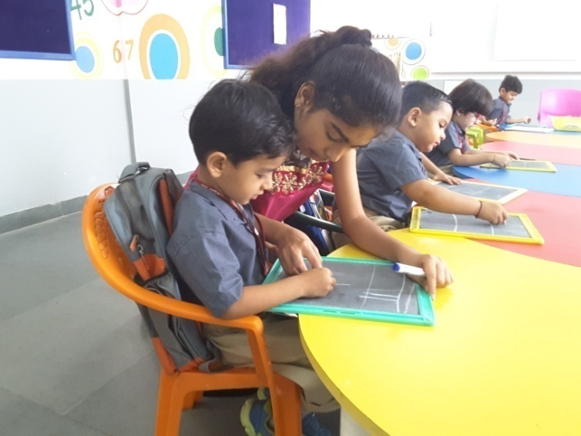
EXPERIMENTS WITH ORIGAMI
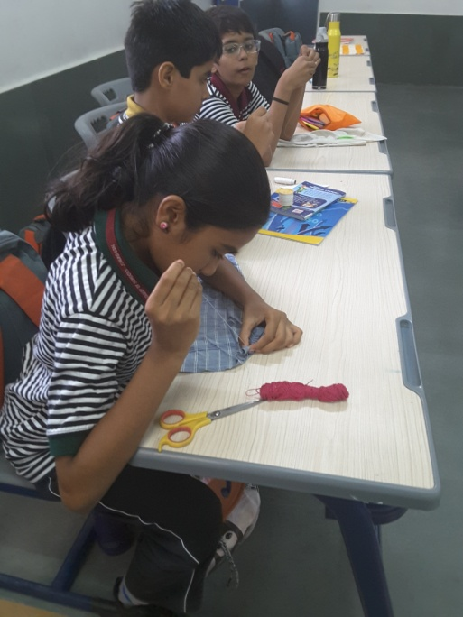

YASHVI A GRADE VIII STUDENT ON ROLE OF A TEACHER
NEEDLE WORK

Future Artists at Eklavya Global School
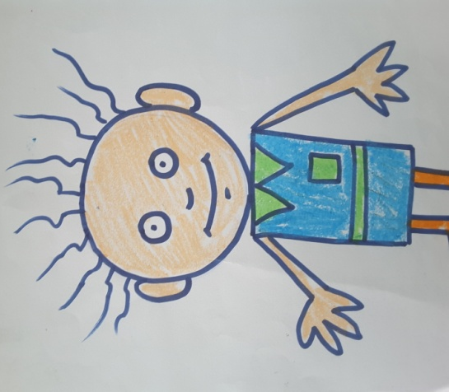
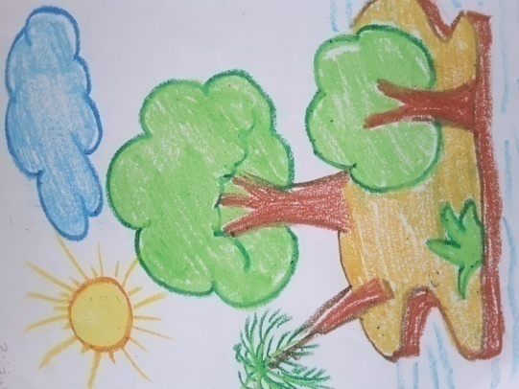
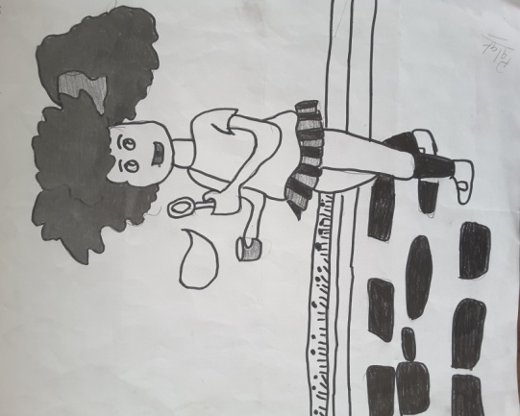

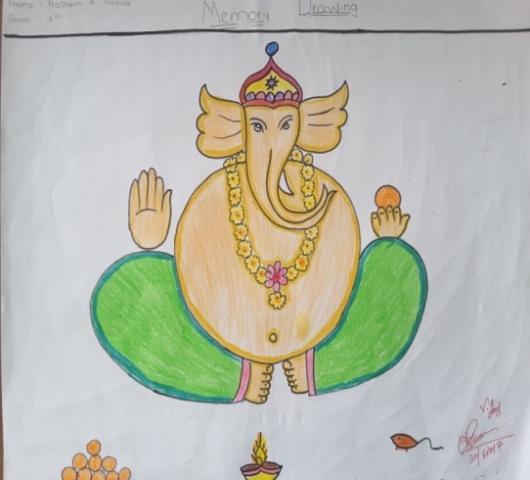
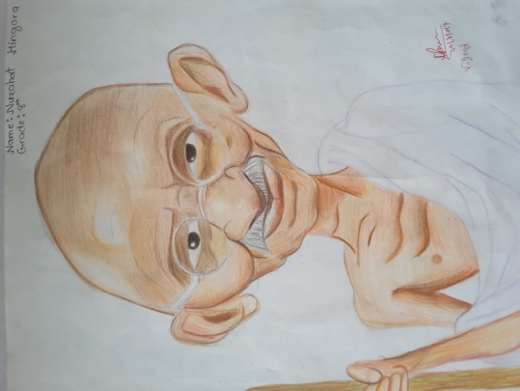
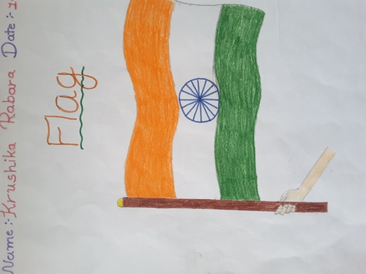

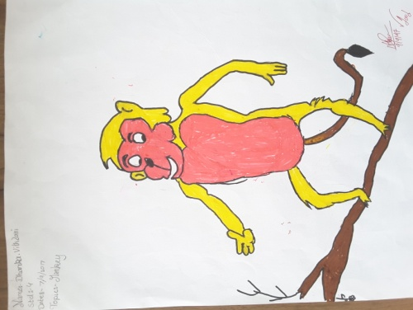
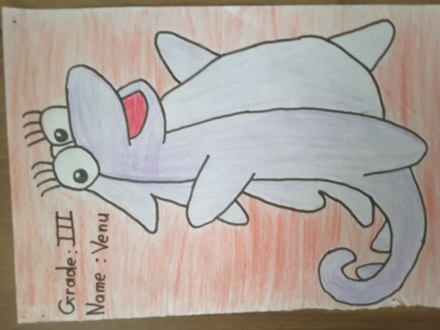
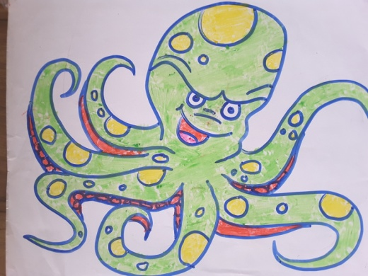

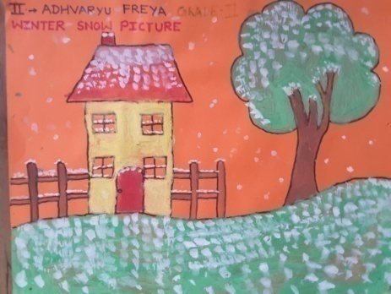
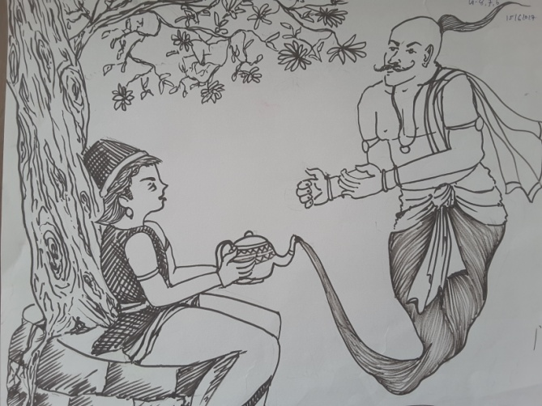
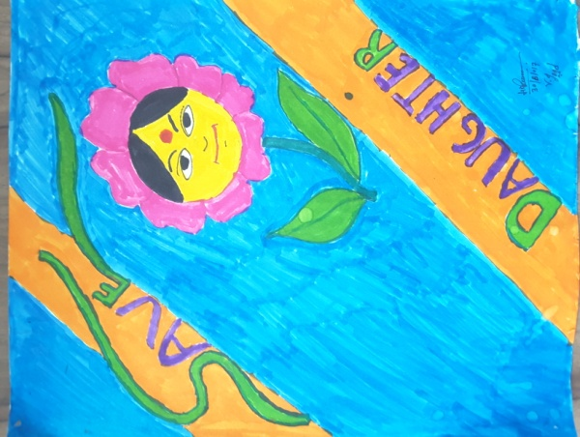
This Newsletter is the fruit of the combined efforts of ‘all and everyone’, hence sans an Editorial board.

